A

PROJECT REPORT

ON

*“Billing Software”*

SUBMITTED TO



PUNYASHLOK AHILYADEVI HOLKAR SOLAPUr University, SOLAPUR

***BY***

Mr Magar Mayur Malhari

Mr Nanavare Harishchandra Dnyaneshwar

**BACHELOR OF COMPUTER SCIENCE (BCS III)**

Shriram Institute of Information Technology, Paniv

**[2022-2023]**

**Under The Guidance Of**

**Prof. Tamboli.F.A.**

“Shriram ShikshanSantha’s”

SHRIRAM INSTITUTE OF INFORMATION TECHNOLOGY, PANIV.

Tal:-Malshiras, Dist:-Solapur.



CERTIFICATE

Date: / /2022

This is to certify that,

The report entitled **“billing software”** has been carried out by Magar Mayur Malhari And Nanware Hairshchandra Dnyaneshwar In project fulfillment for award of Degree in Bachelor of Computer Science (BCS-III) as per the requirement of ***Punyashlok Ahilyadevi Holkar solapur University****,* ***Solapur*** in academic year 2022-2023.

SEEN BY

Project Guide External Examiner Head of Department

**ACKNOWLEDGEMENT**

The development of system involves contribution of time & efforts of many peoples. We have acknowledged their help individually by expressing our hearts gratitude to all of them.

We must express our sincere thanks to principal **Dr. Gadare Sir.** and head of department **Prof. Dawkare R. R.** &***Prof. Tamboli.F.A.***entire staff for their valuable guidance & supports. Our deep sense of gratitude also goes to all friends who help us for successful completion of project.

We must express our sincere thanks to **Prof. Tamboli.F.A.**for giving more valuable & more details information about “**Billing Software.”**

This report would not be in your hands without the help of many besides of our self. We must express our gratitude towards our projects guide **Prof. Tamboli.F.A.** for his guidance & giving us good direction while working on project.

Every work is outcome of full proof planning, continuous hard work and organized

**Thanking You,**

Mr. Magar Mayur Malhari

Mr. Nanware Harishchandra Dnyaneshwar

**INDEX**

|  |  |
| --- | --- |
| **Sr. No.** | **Contents** |
| 1) | **Introduction To Project**  1.1)Login Profile  1.2)Introduction To System  1.3)Scope Of System  1.4)Purposes Of System |
| **2)** | **Analysis**  2.1)Fact Finding Technique  2.2)Feasibility Study  2.3)Hardware & software Requirements |
| **3)** | **System Design**  3.1) Data Flow Diagram  3.2)Context Level Diagrams  3.3) ERD  3.4)Data Dictionary |
| **4)** | **System Design** |
| **5)** | **Reports** |
| **6)** | **Advantages & Limitation** |
| **7)** | **Future Enhancement** |
| **8)** | **Bibliography** |

**INTRODUCTION**

Billing Software is a to introduction to a Kirana bill generator.

* The project Billing Software is a system for managing the various activities in the Kirana Store.
* It manages the Customer information, Product details, Bill information and Bill printing of the hostel
* Billing Software using computerized system this system is automatically Calculate all the Product Bill.
* This system is Reduce the manually work.
* It requires less time faster and its software connectivity to each and its terminal Billing Software there are many Customers comes in the Kirana Store from other facility in the Billing Software.
* Provides more accurate Greater compatibility.

**SCOPE**

The aim of the project is to Computerized all Customer Bill generating. the developed project will deal with the computerized stores details of the Customers related information Customer, Product name, Price, Bill information details, Customer record etc.

* Display all Propertiy Billing Software.
* Display all Bills to a Separate Bill.
* Create New Bill Number to New User.
* New User New Login.

**PURPOSES OF SYSTEM**

The purpose of this System as follows:

* System needs store information about new.
* System need to maintain Bills.
* System need to maintain Tax and Price.
* System need to update and delete the record.
* System also needs a search Bills.
* It also needs a security system to prevent data.

**EXISTING SYSTEM PROBLEM**

Existing System all Billing Software maintain manually while doing this task computer & laptop following used in the solve problem.

* Difficult to handle.
* Low security.
* More human error.
* Data redundancy.
* Record keeping is difficult.

**ANALYSIS**

**2.1) FACT FINDING TECHNIQUE:-**

This information is primarily used to understand the problem of the user and nature of operation and how each activity takes place information of customers. Following are some tools used for fact finding techniques:-

1. **Customer Information:-**

We take the information of customer includes Name, Email id, Password.

**2**.**Product Check:-**

Which Products is customer choose or take.

1. **Bill Generation: -**

**Then we generate a bill**.

**2.2) FEASIBILITY STUDY:-**

It provides you with information on the Customer requirement and bill generating. The goal is to determine whether or not it makes sense to go forward with the project. The following three aspects of feasibility study were carried out.

**1) Technical Feasibility:-**

This Feasibility Describes the current equipment existing software, number of people available in the

Organization related with the software. The computerized “Television cable System” follows all the technical parts affected to technical views. This system does not require any specific type of Hardware.

**2) Economical Feasibility:-**

System is developed in MS Access and Visual Studio 8 which is open source technology can be easily available.

This system is not costly .this system is suitable for Billing Software. This system is economically suitable for Billing Software. This System gives us detail information of Customer, Product, Price, Details etc.

**3) Operational Feasibility:-**

It requires minimal knowledge on part of the user to handle the system. The system is user friendly and interactive with provision of appropriate and effective messages. The system is general purpose**.**

**2.3) HARDWARE & SOFTWARE REQUIREMENT:-**

**Hardware Requirement:**-

**System development using following hardware configuration**

Processor : CORE (i3) DUAL CPU.

RAM : 1 GB RAM.

HDD : 512 GB

**Software Requirement:-**

**System development using following software**

Operating System : Windows 11.

Developing Tool : Visual studio Code

Database : MySQL.

**SYSTEM DESIGN**

**DATA FLOW DIAGRAM:-**

## Data flow diagram

Adataflowdiagramisgraphicalrepresentationthatdepictstheinformationflowandthetransformsthatrappliedasdate movesfrominputtooutput.Itcanbe usedtorepresenta software at any level of abstraction. In fact DFDs may be partitioned in to levels.Thatrepresents increasinginformationflowandfunctionaldetails.

DFDsaredefinedinlevelswitheveryleveldecreasing thelevelofabstractionaswellas defining a greater detail of the functional organs of the system. A zero level DFD alsoknown as context or fundamental system model represents the entire software elements as asingle bubblewith input and output data entities which are indicated as incoming andoutgoing arrows. Data Flow Diagram help understanding the basic flow of data from oneprocess to another process. This 0 level DFD represents fundamental overview of the billingsystem.

Customer

Viewproducts

lingstem

OrderProduct

BillReport

ViewCustomerRecordAddCustomer

BilSy

ViewOrder

**Thisisthe 1-LevelDFDforthebilling syste**AddProduct

**m.Thisprovides**

**inbetweentheprocessesofthebilling**

**system.Itismoredescribestheflow of**

**thedetailedofthedataflowing**

**information.Billingsystemconcern**

AddCategory

**withthe**

**customer’schoiceofproductsothere isa**

**Productprocessingprocessthe**

**0-LEVEL**

**orderof**

**customeraccordingtothechoice. Twoanotherprocessisthereforfurtherprocessingoftheorderandcustomersinformationinbillingsystemdatabase.**

Administrator

Customer

1.2

OrderProcessingBillReport

Order_Details

OrderProduct

ViewCustomerRecord

Add

1.3

CustomerRecordProcessing

ViewProducts

Customer

AddProducts/Category

1-levelDFD

1.1

ProductProcessing

Administrator

**SCREEN SHOTS:-**

**1. Home Page:-**

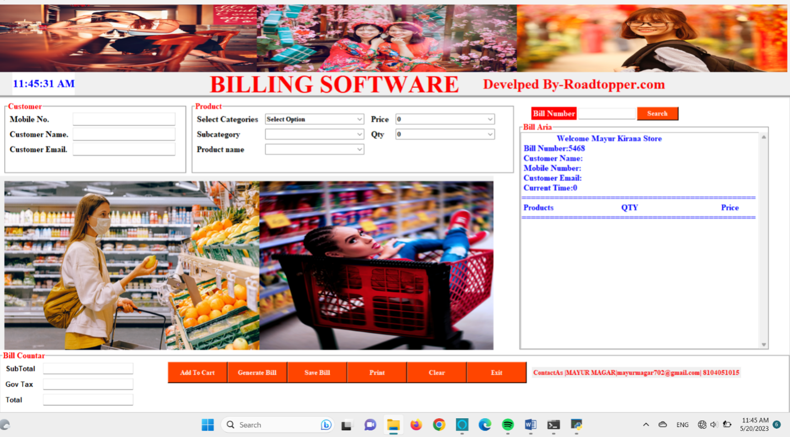

**2.Login Page**

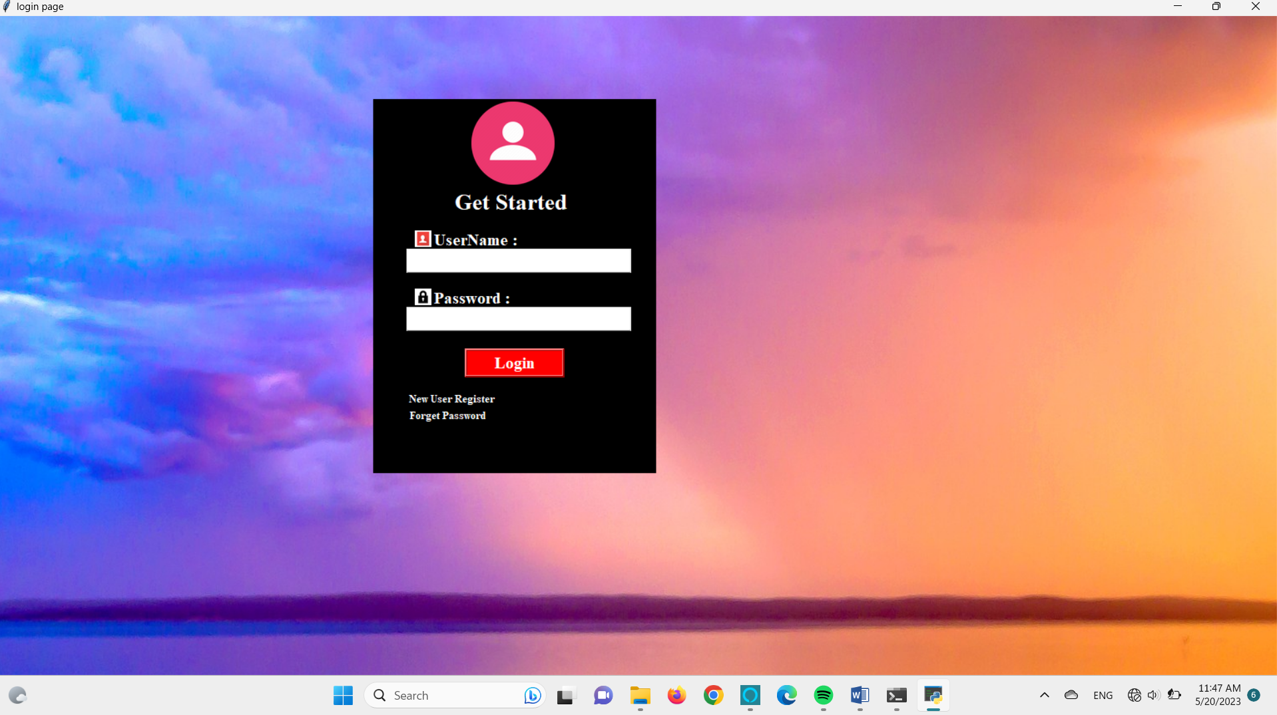

**3.New Registration**

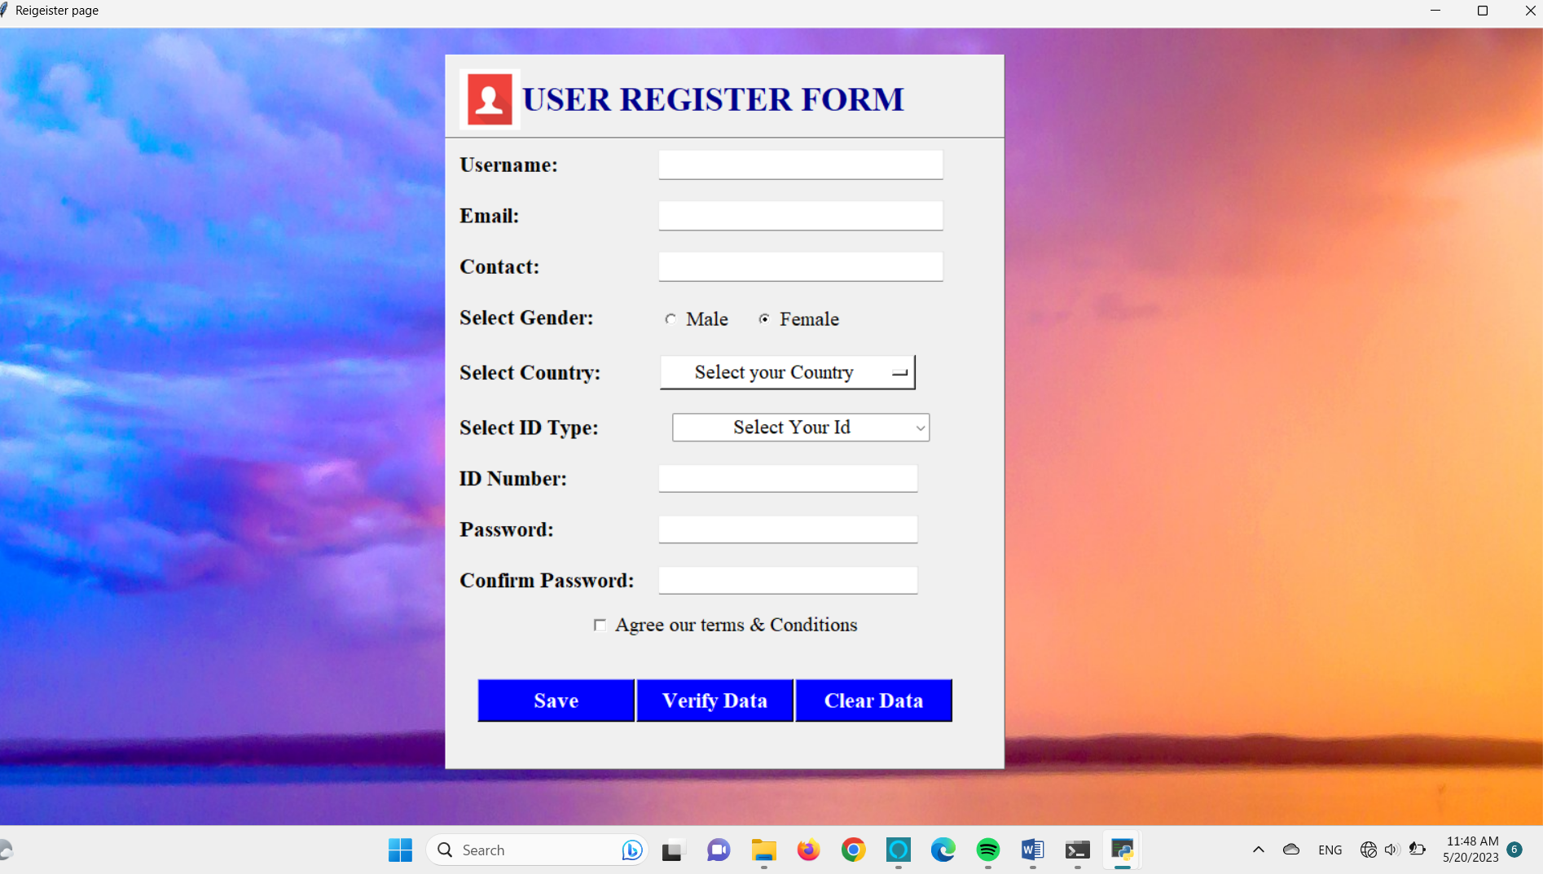

**4.Text and Voice Validation**

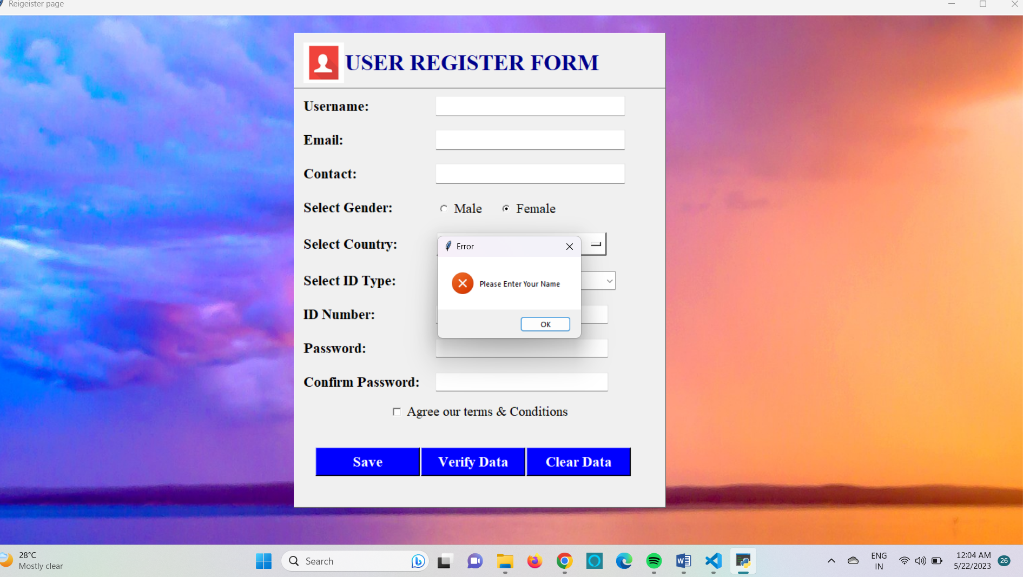

**5.Forget Password**

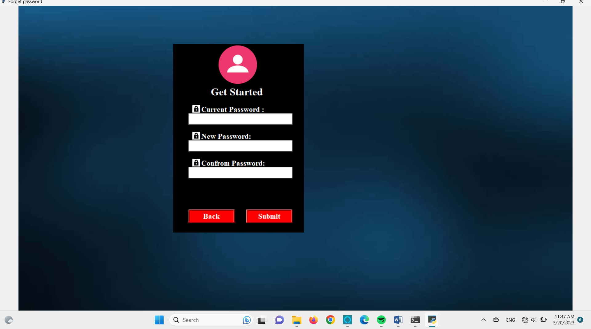

**Report:-**

Output Type:-

1. User Login Database :-

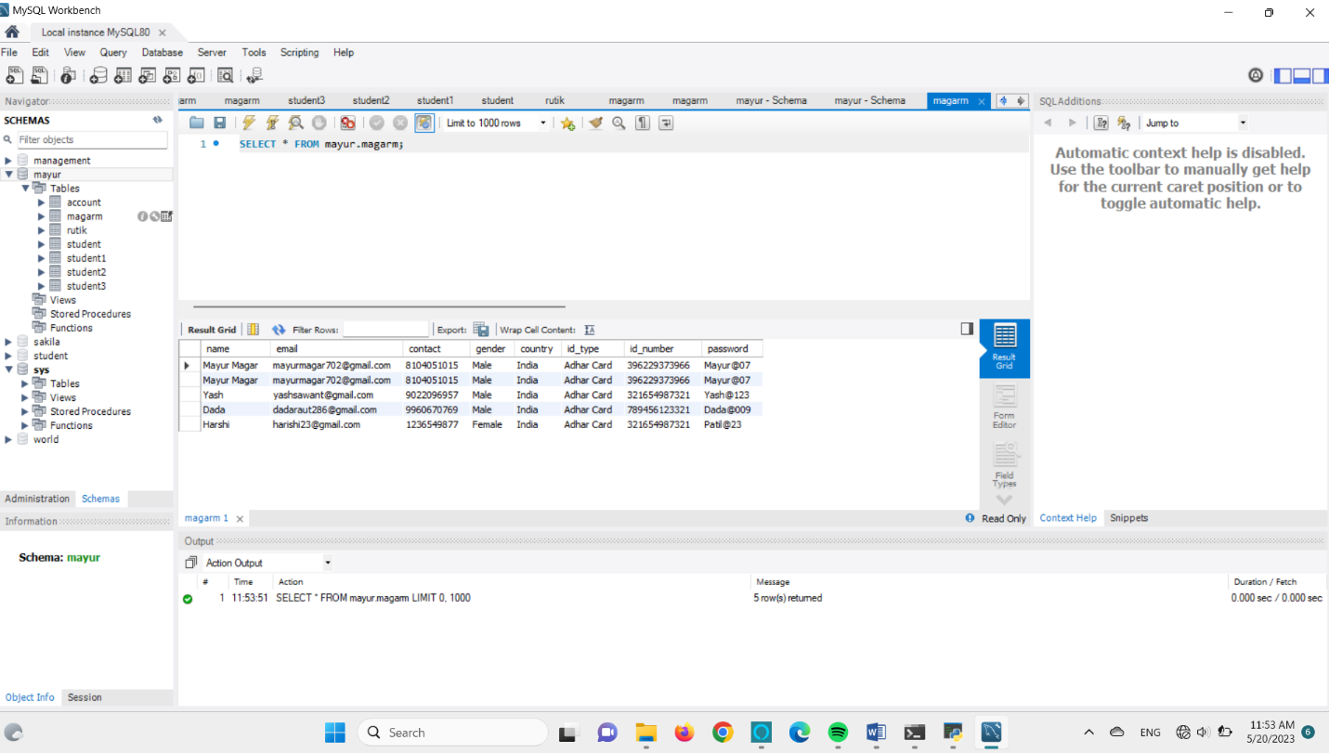

4. Txt Files:-

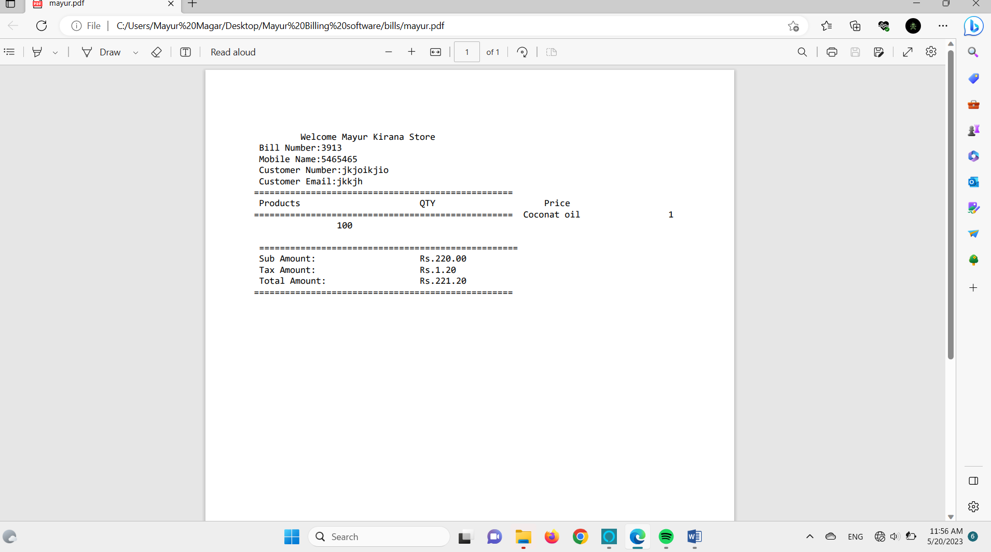

**4. Bills Saved Folder**

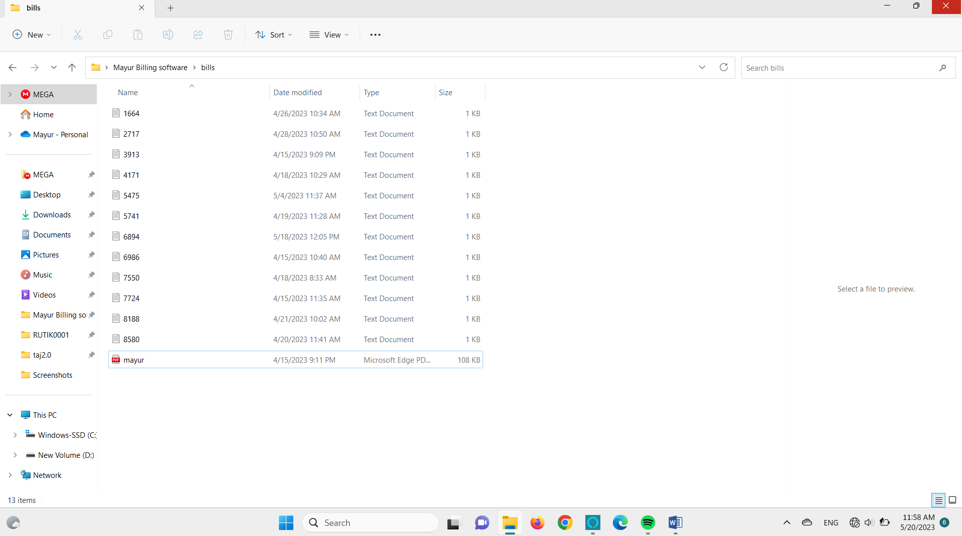

**DATA DICTIONARY**

**LOGIN TABLE**

|  |  |  |
| --- | --- | --- |
| **NAME** | **NULL?** | **TYPE** |
| USERNAME | NOT NULL | VARCHAR(45) |
| PASSWORD |  | VARCHAR2(30) |
| USER_EMAIL |  | VARCHAR(45) |
| USER_MOBILE_NO |  | NUMBER(10) |
| IDENTITY_NO |  | NUMBER(30) |
| CONFROM PASSWORD |  | NUMBER(12) |

**ADVANTAGS &LIMITATION:-**

**ADVANTAGE:-**

* To store and retrieve the details of user.
* To generate Bills as and required by concerned.
* Help to saving time, work.
* All information is stored as per Bill Number.
* User having facility of login for security purpose.

**LIMITATION:-**

* Limit store data as per integer data type.
* Time consuming process as all the entries is manually written.
* This system is design to stand alone, does not work on Network site.

**FUTURE ENHANCEMENT**

* It will gives report responding to user requirement.
* Incorrect data is entered is not executed, gives an error.
* Due to this system value of registered of manually handled are avoided.
* It will reduce administrative work and operating cost.
* It will give faster response implies the reduction in turnaround time.
* Number of report will have to be generated.

**Conclusion:**

1. **In conclusion, the development of the billing software for your college project has been a significant achievement. This project aimed to automate and streamline the billing process, providing an efficient and reliable solution for managing financial transactions within the college.**
2. **Throughout the project, various objectives were accomplished, including designing a user-friendly interface, implementing secure data storage and retrieval, integrating necessary functionalities, and ensuring accurate calculations and invoicing. The software successfully meets the requirements specified in the project scope, offering a robust and efficient billing system.**
3. **By developing this software, you have contributed to enhancing the efficiency and effectiveness of the college's financial management processes. The software provides numerous benefits, such as reducing manual errors, improving billing accuracy, saving time, and enabling easy tracking of financial transactions. Additionally, the system's security measures ensure the confidentiality and integrity of sensitive data, safeguarding against unauthorized access.**

**During the development process, you gained valuable skills and knowledge in software design, database management, user interface development, and programming. This project has not only showcased your technical expertise but also demonstrated your ability to understand and meet user requirements.**